PRESS RELEASE

The city of Worcester is to commemorate ‘Mayflower 400’ with a ‘World Premiere’ Gala Concert, to be performed by a 200-strong choir – the Worcestershire Mayflower Chorus - featuring youngsters from across the region and tutored by internationally renowned choral conductor, Neil Ferris.

Joined by the English Symphony Orchestra together with hand-picked soloists, the programme will celebrate Worcestershire’s famous Mayflower pilgrim, Edward Winslow, and the subsequent momentous ties which were formed between England and America.

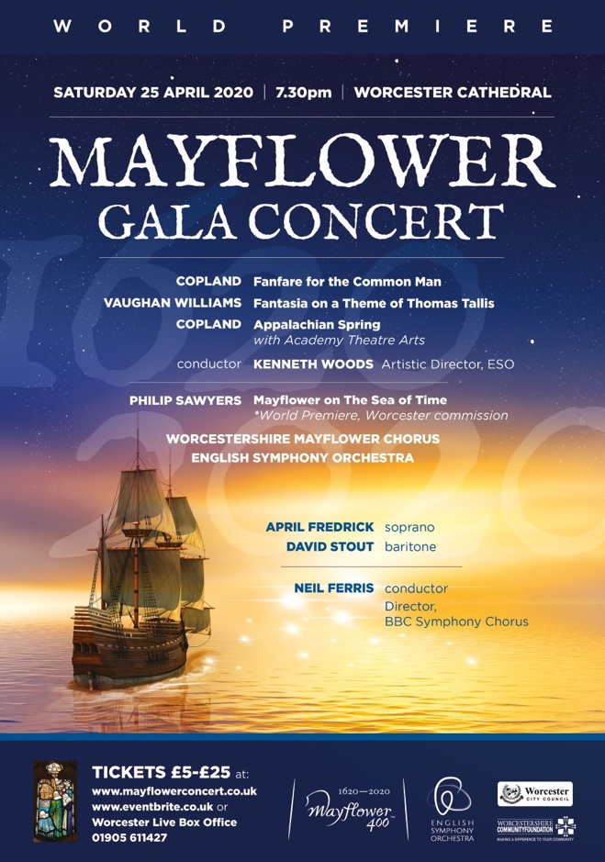

City of Worcester commemorates ‘Mayflower 400’
As one of the highpoints of the city’s commemorations to mark the 400th anniversary of the Mayflower’s pioneering voyage to the New World in 1620 and Worcestershire’s strong connection to this momentous and far-reaching event, the Gala Concert will take place in Worcester Cathedral on Saturday 25 April 2020.

Worcestershire’s famous Mayflower passenger was pilgrim Edward Winslow who became Governor of Plymouth Colony three times over, was a leading diplomat, politician and peacemaker, and is largely attributed with having established ‘Thanksgiving’.

‘World Premiere’ occasion
As well as audience orchestral favourites by Vaughan Williams and Copland performed by the English Symphony Orchestra under their conductor Kenneth Woods, the Gala Concert programme is to include the World Premiere of a specially commissioned choral/orchestral work: Mayflower on the Sea of Time, written by British composer Philip Sawyers.

Local youngsters to benefit from performance opportunities
Offering young people in Worcestershire access to the finest performance opportunities, the specially formed Worcestershire Mayflower Chorus – a 200-strong choir of students and teachers – will perform the commissioned work alongside the ESO and soloists April Fredrick, soprano and David Stout, baritone, under conductor Neil Ferris.

Students from Worcester’s Academy Theatre Arts will join the performance of Copland’s Appalachian Spring in a dance of celebration performed around the cathedral, choreographed by college principal, Helen Leek.

Vibrant young voices
The concert is the culmination of an inspired educational project with Worcestershire secondary schools and colleges under the direction of esteemed choral conductor, Neil Ferris, who is Director of the BBC Symphony Chorus, amongst other eminent choirs, and recognized as one of the country’s leading teachers of choral conducting.

“I am very excited about returning to Worcester to work with incredibly talented secondary school students and their dedicated teachers for what promises to be a rewarding and life-long memorable event”, said Mr Ferris. “We have commissioned a superb piece from Philip Sawyers, which will make a significant contribution to the cultural events taking place nationally and internationally in this Mayflower 400 year.”

Philip Sawyers added: “My task as a composer was to write a substantial work to commemorate this event and the challenges the Pilgrims faced in the New World. The work is in four parts telling of the persecution and journey, arrival in the New World, survival and community and ‘The Sea of Time’, which includes a reflection of the mystic qualities of the natural world using words by one of America’s most iconic poets, Walt Whitman. Finally, a celebration and the first ‘Thanksgiving’ brings the work to an affirmative close.”

- Ends -

Further information for editors:

Worcestershire’s ‘Mayflower 400’ in context
Worcestershire’s Mayflower programme is an ambitious year-long commemoration marking the 400th anniversary of the Mayflower’s pioneering voyage, telling the story of a ship and its passengers - a group of people that a remarkable 30million+ US citizens have descended from. Drawing on the region’s exceptional heritage assets and organisations to create a memorable series of activities while also promoting wider links with the US.

Mayflower on the Sea of Time was commissioned in response to Worcestershire’s part in the Mayflower story. The project’s legacy will be its impact as a major cultural event for the Mayflower commemorations, a recording, and further performances as the work takes on a journey of its own promoting Worcestershire’s cultural heritage and history.

The Worcestershire Mayflower Chorus
Formed in partnership with Worcestershire schools and supported by Severn Arts, the chorus comprises students and teachers from: Arrow Vale RSA Academy, Bishop Perowne CofE Academy, The Chase Malvern, Christopher Whitehead Language College, Dyson Perrins Academy, King’s Worcester, Malvern St. James, Pershore High School, South Bromsgrove High, University of Worcester, and the girl choristers of Worcester Cathedral Choir.

The project follows a successful 10-year programme of high quality choral singing projects for young people in Worcestershire that have resulted in outstanding public performances. Each project has enabled young people to perform alongside professional orchestras, artists and conductors.

Event details and booking information: www.mayflowerconcert.co.uk

For further information, review tickets, interviews and images:
Anne Renshaw, Project Producer
annerenshaw@me.com / 07810 823322
or
Karen Fletcher, Archery Music Promotions
archerypromos@btinternet.com 07973 175588

Rob Byrne, PR Manager Worcester City Council
Rob.Byrne@worcester.gov.uk

Neil Ferris
Chorus Director, BBC Symphony Chorus, Chorus Director, Royal College of Music, Artistic Director, Sonoro, Music Director of Wimbledon Choral Society
neilcpferris@hotmail.com

Philip Sawyers, composer
www.philipsawyers.co.uk

English Symphony Orchestra (ESO)
The International Orchestra of Elgar Country
www.eso.co.uk

Kenneth Woods, Principal Conductor/Artistic Director, ESO
www.kennethwoods.net

Social Media:
Twitter: @WorcsMayflowerC Facebook:@Worcs.MayflowerChorus

